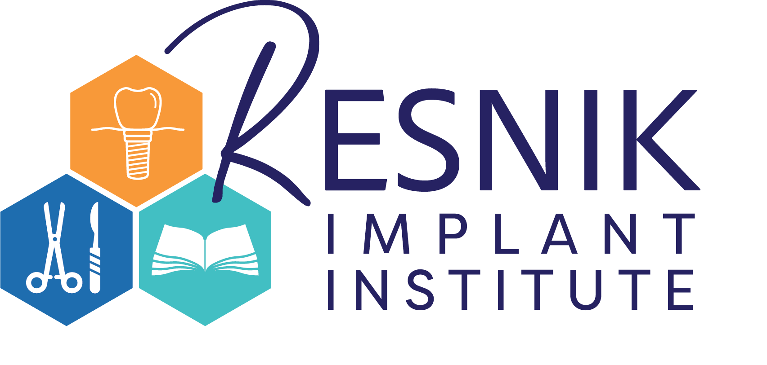
All-On-X FULL ARCH IMPLANT CONSENT FORM

Patient's Name: ____________________________________________________ Date: _______________

This document provides detailed information about your proposed dental implant procedure, including alternative treatments, the proposed treatment, and associated risks. I understand the nature of All-On-X procedures include two separate treatments; (1) Surgical Phase – placement of dental implants, and (2) Prosthetic Phase – insertion of prosthetic teeth. Please review this information thoroughly, if you have any questions, kindly consult your doctor BEFORE initialing each section.
Introduction (Initials __________)
I acknowledge and agree with the proposed recommendations for the treatment of my existing dental (mouth) condition. I have been thoroughly informed about alternative treatments, including their associated risks and benefits, as well as the option of no treatment. I have asked any and all questions and the answered have been provided to my satisfaction.
I have been advised that I may seek additional care to preserve and maintain any teeth that are currently in my mouth. I understand these additional treatments may include periodontal (gum disease), endodontic (root canals), orthodontic (braces), and/or general dental care. Having been advised of and considering these options, knowing of these alternative forms of treatment to preserve my teeth, I have elected to have any remaining teeth extracted (removed) for the final prosthetic rehabilitation of my mouth to include a fixed prosthesis (Implant Supported Non-Removable Bridge)

Surgical Procedure (Initials __________)
I understand the first phase of treatment includes a surgical procedure and have been informed what is necessary to accomplish the placement of the implants (and any associated bone grafting) and attaching (insertion) of the fixed bridge(s). I understand that no guarantees can be or have been made to me about the success of these procedures. I agree to cooperate with my doctor’s recommendations and advice prior to and following this procedure knowing that not doing so may result in the failure of my implants and/or prosthesis (fixed bridge).
I also authorize and direct my doctor(s) and associates, to provide such additional services as they may deem reasonable and necessary, including but not limited to; the administration of anesthetic agents, the performance of necessary laboratory, radiological (X-Ray/Cone Beam CT scan) and other diagnostic procedures, and the administration of medications orally or by injection.
I have been advised in some situations, bone grafting procedures may be indicated which may include autogenous (my own bone), allograft (cadaver bone), or zenograft (animal bone). These types of bone are used to augment (increase) the available bone for the support of the implants and prosthesis. Therefore, I understand the nature of these possible procedures and I consent to the procedure knowing its risks and limitations.
Recognizing that complications are inherent in any surgical procedure, I understand and accept the possible risks, including, but are not limited to post-surgical infection, bleeding, swelling, pain, facial discoloration (bruising), muscle spasms, jaw problems, sinus problems, poor healing, numbness (paresthesia) of the lip, chin and tongue (i.e., which is usually temporary, but, on occasion, may be permanent). The development of any of these aforementioned risks may result in the need for surgical removal of the implant(s)/bone graft and/or the replacement and/or modifications of the existing treatment plan. Additional costs may be associated with complications of treatment.
Anesthesia/Sedation (Initials __________)
I acknowledge that in addition to the risks and complications associated with implants and prosthetics, certain complications may result from the use of anesthetics or sedatives. The risks, benefits and alternatives related to anesthesia has been thoroughly explained to me. I have disclosed all medical information to my doctor, recognizing that it may impact my response to these medications. If administered oral or IV sedation, I agree not to operate a motor vehicle, hazardous device, or make important decisions for up to twenty-four hours or until fully recovered from the effects of the sedative drugs.

Prosthetic Procedures (Initials __________)
I recognize the importance of avoiding excessive biting forces to prevent damage to my implants/prosthesis, as is crucial with any dental prosthesis. I commit to adhering to recommended nutritional protocols, gradually introducing hard foods into my diet to mitigate excessive force-related issues. I understand that habits such as tooth clenching (grinding) and consuming foods requiring aggressive chewing (ice, hard candy, etc.) can elevate the risk of prosthesis damage. If advised, I understand that I may need to wear an occlusal guard (nightguard) to protect the implants/prosthesis.
The following are possible prosthetic complications which include, but not limited to; risk of prosthetic and/or material fracture which will require repair, compromised bite relationship, compromised esthetics, food entrapment, impaired speech requiring a period of adaptation, loss of prosthesis and/or implants due to fracture or periodontal/systemic disease.
I understand the final implant fixed prosthesis will likely include the use of pink material (acrylic, porcelain, zirconia) in conjunction with the final crown (tooth colored material) due to bone and tissue loss. Additionally, this may result in a space between the prosthesis and the tissue surface.
Unanticipated Conditions (Initials __________)
During the course of treatment, unforeseen oral conditions may arise that could modify or necessitate a change to the original treatment plan. In the event of such situations, I hereby authorize and direct my doctor(s) to undertake whatever measures they deem necessary and advisable under the circumstances. This may include the modification of the procedure or the decision change the treatment plan.
General (Initials __________)
I have been advised that the use of tobacco, alcohol, and various systemic diseases may affect the health of the implant and prosthesis, which may limit the success of the treatment. I agree to follow my doctor's instructions for home care, oral hygiene and agree to follow my doctor's instructions for follow-up care and treatment. Additionally, I consent to photography and x-rays for educational purposes, as long as my identity remains confidential.
Summary (Initials __________)
I am aware that the practice of dentistry is not an exact science and I acknowledge that no guarantees have been provided to me concerning the success of my implant prosthesis and the associated treatment and procedures. Understanding the potential for the implant surgery and/or prosthesis to fail, which may necessitate further corrective surgery, including implant removal and the creation of a new or modified prosthesis, I acknowledge that an additional fee may be charged for such procedures.
I agree to follow my doctor’s post-operative instructions and to immediately notify them of any problems that may develop. I willingly assume any and all possible risks, including the risk of substantial harm, associated with any phase of this treatment, in the hope of achieving the desired potential results, recognizing that success may or may not be attained.
The fees for these services have been explained to me, and I find them satisfactory. By signing this document, I voluntarily give my consent to authorize treatment by my doctor or associates. I affirm that I have read and fully understand the terms and language within this document, including the explanations referred to or implied.
I, ______________________________, read and understand English and have initialed the above statements.
Patient (print): _________________________________________________ Date: ______________________
Patient signature: ______________________________________________
Doctor Signature: ______________________________________________

