Consent for Anesthesia

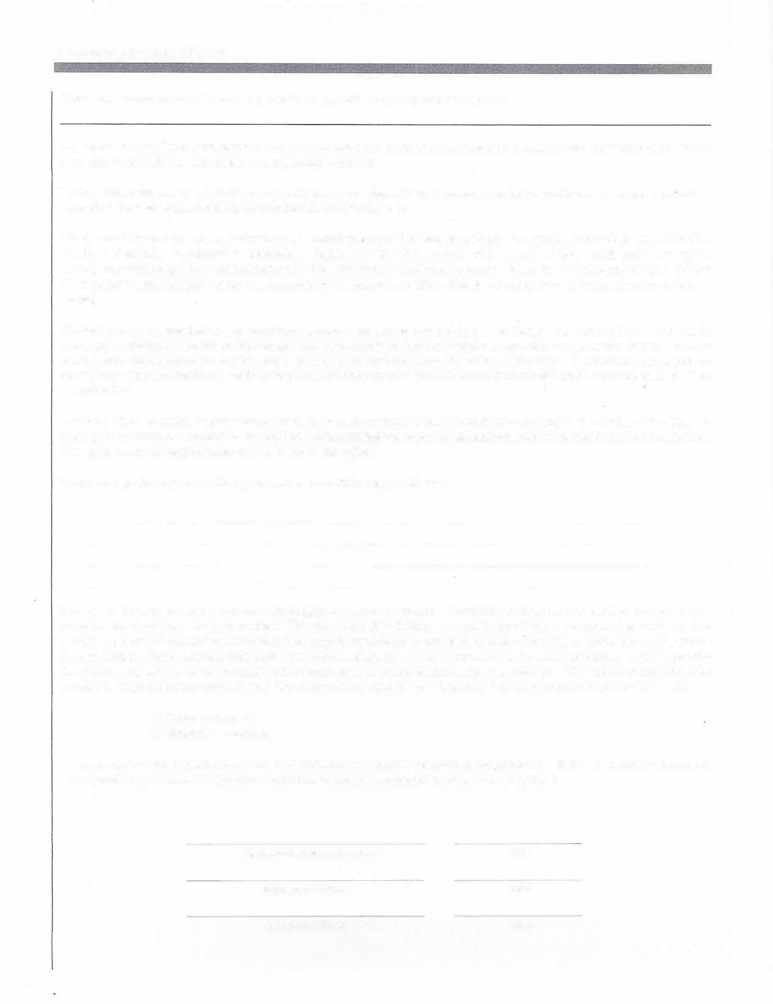

This is my consent for the doctor or any dentist or physician who may be employed by:

to perform the oral dental procedures on my examination chart, as previously explained to me, and any other procedure deemed necessary or advisable as a corollary to the planned operation.

I also agree to the use of a , □ oral sedation, □ IV sedation and analgesia depending upon the judgment of the dentists/physicians involved with my care.

I have been informed that occasionally there are complications of the treatment, drugs and anesthesia including: pain, infection, swelling, bleeding, discoloration, numbness, tingling of the lip, tongue, chin, gums, cheeks, teeth pain, numbness, tingling and thrombophlebitis (inflammation of the vein), from intravenous injection, injury to and stiffening of the neck and facial muscles, referred pain to the ear, neck and head, nausea, vomiting, allergic reaction, bone fractures, bruises or delayed healing.

Medications, drugs, anesthetics and prescriptions may cause drowsiness and lack of awareness and coordination which can be increased by the use of alcohol or other drugs; thus, I have been advised not to operate any vehicle or hazardous devices, or work while taking such medications and/or drugs, or until fully recovered from the effect of the same. I understand and agree not operate any vehicle or hazardous devices for at least 24 hours or until fully recovered from the effects of such medications, drugs or anesthetics.

I acknowledge the receipt of pre-operative instructions and understand that I should have nothing to eat or drink for at least six hours prior to receiving anesthetics. In addition, I acknowledge the receipt of and understand post operative instructions and have been given a specific appointment date to return to the office.

I acknowledge that my health history has revealed the following conditions:

!.

2.

3.

4.

Because of these conditions, it has been thoroughly explained to me and I completely realize that any surgical procedure may, therefore, be classified as a risk procedure. The risk involved is defined as a greater possibility of experiencing morbidity (the relative incidence of disease) and mortality (the proportion of death to population), during the surgical procedure, than a person in good health. These complications which can occur during surgery may involve more than average amount of post-operative discomfort, increased pain and swelling and delayed healing. I fully acknowledge that these possible complications have been explained. With clear knowledge of all of these possible complications, I requested that the procedure be performed in the:

______ Office environment

______ Hospital environment

I may request further explanations of the risks involved and possible outcome of the procedure. When the patient is a minor or incompetent to give consent, signature should be of a person authorized to consent for the patient.

Signature of Patient or Guardian Date

Signature of Witness Date

Signature of Doctor Date